***EXERCISE 1: SETTING UP JUnit***

**Scenario**: You need to set up JUnit in your Java project to start writing unit tests.

***CalculatorTest.java:***

import org.junit.Test;

import static org.junit.Assert.*;

public class CalculatorTest {

@Test

public void testAdd() {

Calculator calc = new Calculator();

int result = calc.add(2, 3);

System.out.println("✔ add(2, 3) = " + result); // Add this line

assertEquals(5, result);

}

}

***Pom.xml(JUnitDemo):***

<project xmlns="http://maven.apache.org/POM/4.0.0"

xmlns:xsi="http://www.w3.org/2001/XMLSchema-instance"

xsi:schemaLocation="http://maven.apache.org/POM/4.0.0

http://maven.apache.org/xsd/maven-4.0.0.xsd">

<modelVersion>4.0.0</modelVersion>

<groupId>com.example</groupId>

<artifactId>JUnitDemo</artifactId>

<version>1.0-SNAPSHOT</version>

<dependencies>

<dependency>

<groupId>junit</groupId>

<artifactId>junit</artifactId>

<version>4.13.2</version>

<scope>test</scope>

</dependency>

</dependencies>

</project>

***Calculator.java:***

public class Calculator {

public int add(int a, int b) {

return a + b;

}

}

***OUTPUT:***

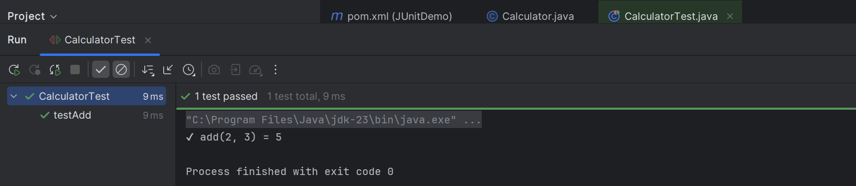

***EXERCISE 3: ASSERTIONS IN JUnit***

**Scenario:** You need to use different assertions in JUnit to validate your test results.

***AssertionsTest.java:***

import org.junit.Test;

import static org.junit.Assert.*;

public class AssertionsTest {

@Test

public void testAssertions() {

System.out.println("Running assertions...");

// Assert equals

assertEquals(5, 2 + 3);

System.out.println("assertEquals passed");

// Assert true

assertTrue(5 > 3);

System.out.println("assertTrue passed");

// Assert false

assertFalse(5 < 3);

System.out.println("assertFalse passed");

// Assert null

assertNull(null);

System.out.println("assertNull passed");

// Assert not null

assertNotNull(new Object());

System.out.println("assertNotNull passed");

System.out.println("All assertions passed successfully.");

}

}

***Pom.xml(AssertionsJUnitProject):***

<project xmlns="http://maven.apache.org/POM/4.0.0"

xmlns:xsi="http://www.w3.org/2001/XMLSchema-instance"

xsi:schemaLocation="http://maven.apache.org/POM/4.0.0 http://maven.apache.org/xsd/maven-4.0.0.xsd">

<modelVersion>4.0.0</modelVersion>

<groupId>com.example</groupId>

<artifactId>AssertionsJUnitProject</artifactId>

<version>1.0-SNAPSHOT</version>

<dependencies>

<dependency>

<groupId>junit</groupId>

<artifactId>junit</artifactId>

<version>4.13.2</version>

<scope>test</scope>

</dependency>

</dependencies>

</project>

***OUTPUT:***

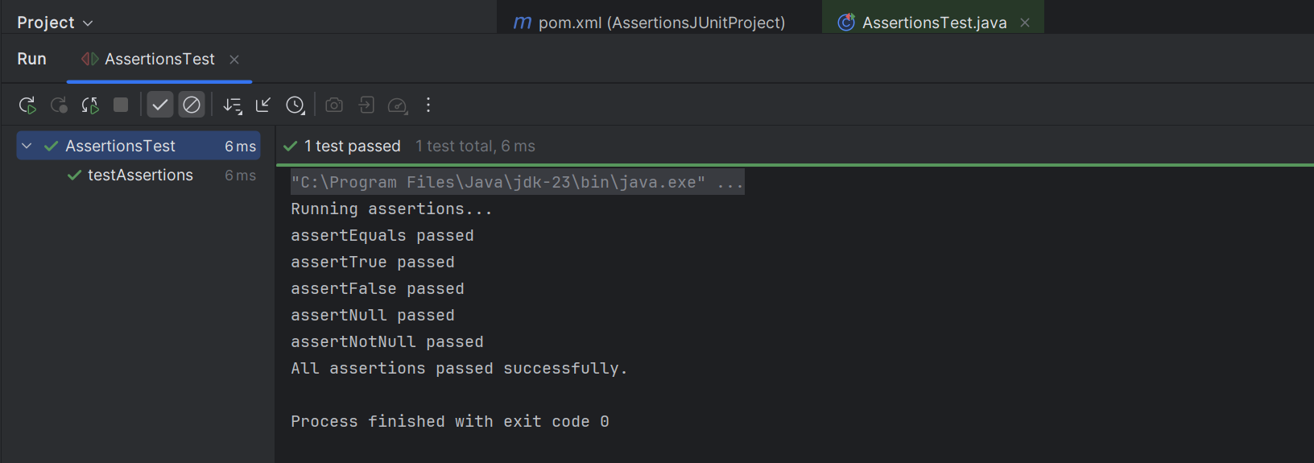

***EXERCISE 4: ARRANGE – ACT – ASSERT(AAA) PATTERN , TEST FIXTURES, SETUP AND TEARDOWN METHODS IN JUnit***

**CalculatorTest.java:**

package com.example;

import org.junit.After;

import org.junit.Before;

import org.junit.Test;

import static org.junit.Assert.assertEquals;

public class CalculatorTest {

private testAdd()

@Before

public void setUp() {

calculator = new Calculator();

System.out.println("Setup complete");

}

@After

public void tearDown() {

System.out.println("Teardown complete");

}

@Test

public void testAdd() {

// Arrange

int a = 5;

int b = 3;

// Act

int result = calculator.add(a, b);

// Assert

assertEquals(8, result);

}

@Test

public void testSubtract() {

// Arrange

int a = 5;

int b = 3;

// Act

int result = calculator.subtract(a, b);

// Assert

assertEquals(2, result);

}

}

**Pom.xml:**

<dependency>

<groupId>junit</groupId>

<artifactId>junit</artifactId>

<version>4.13.2</version>

<scope>test</scope>

</dependency>

**OUPUT:**

